United Country Ozark Realty
Information Sheet

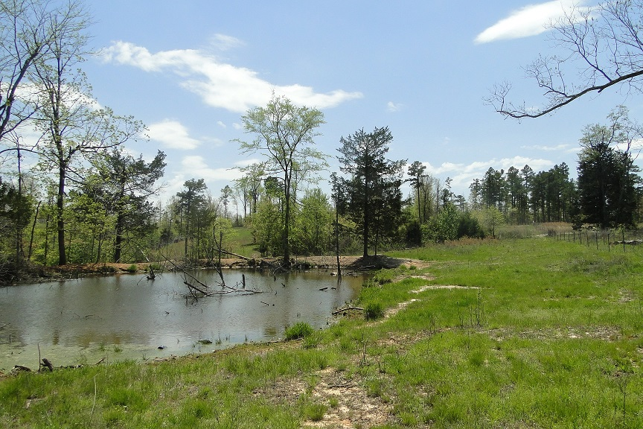
United Country Ozark Realty, Inc.
PO Box 158
Melbourne, AR 72556

Phone: 870-368-4155

Fax: 870-368-4165

Email: ozarkrealtyinc@gmail.com

LISTING #5561

PRICE $425,000

PROPERTY ADDRESS: 111 Hwy 223 South, Wild Cherry, AR 72515
Land | Home
Acres: 409  Water Source: Well/Live Creek  Electricity To Property: Yes  Closest Town: Wild Cherry  Type Of Road: Gravel  Distance to Blacktop: 1/2 Mile  Amount of Cleared Land: 300  Amount of Timber Land: 109  Fencing: Yes  Outbuilding(s): None  Estimated Taxes: $800 | ARKANSAS ACREAGE FOR SALE WITH CREEK  North Central Arkansas Acreage for sale with live creek for under $1,100 per acre in North Central Arkansas. The 409 acre tract is fully fenced with livestock possibilities and several creek bottoms. Great for hunting in the Ozarks! Cleared roads going all throughout the property which offers great access and recreational use! Priced to sell at under $1,100 per acre! Come see this property today! $425,000

